**Round 2**

Experiment 1: **Measuring Pressure Using Piezoelectric Pick up.**

**1.Story Outline:**

This experiment is based on how to measure pressure applied at piezoelectric transducer with the help of differential amplifier and digital meter by calibrating the gain control knob of amplifier.

Firstly the user will make the proper connection of the piezoelectric transducer, differential amplifier and digital meter. After that apply the pressure by selecting the different values shown in the input to be measured at piezoelectric transducer some output is shown at digital meter. Then calibrate the amplifier using the gain control knob in such a way that same output value is shown as input selected numerically. Finally user will directly measure the pressure applied at piezoelectric transducer.

The simulator will perform operations in interaction with user, and value of applied pressure is obtained.

**2.Story:**

This experiment is based on how to measure pressure applied at piezoelectric transducer with the help of differential amplifier and digital meter by calibrating the gain control knob of amplifier.

When user clicks on the simulation button, simulator for the measurement of pressure using piezoelectric transducer opens up.The simulator screen is partitioned into five areas namely Canvas working area, Power switch and equipment area, instruction area, input switches area and last output reading area.

First the working area is the space provided in the simulator so that user place the equipment and draw the circuits according to the instruction shown in the instruction area. In starting there is no equipment in the working area. Then from power and equipment area user firstly switch on the simulator and then select different equipment to completer the circuit. After completing the circuit according to the instruction in the instruction window, if instruction is not followed properly the a message in lower tab is shown. Then switch on the circuit button from input switch area and output is shown in the output reading area.

Then user have to calibrate the output meter with the help of gain control knob of differential amplifier which is provided in the input switch area in such a way that the output shown in the output meter is numerically equal to the applied input pressure. After that apply the pressure which is to be measured and the output is obtained accordingly.

**2.1 Set the Visual Stage Description:**

When the user enters the simulator, he sees a screen divided into 2 columns consisting of two and three rows individually. That indicates that a total of five blocks.

The first block in first column contains our main canvas (circuit board). The second block in first column circuit equipment contain Enable/disable Switch, piezoelectric transducer, differential amplifier, output meter and connecting wires.

The second column, the first-row instructions appear as soon as everyone presses the button of equipments and wires (follow the instructions) they change subsequently. Below that contains Switch to ON the supply and input applied pressure switch.

In, second column and last row shows the output metering box where output is shown in both analog and in digital form.

Instructions are as follows:

Step 1: Click on the ON button to start the Simulator.

Step 2: Now click on selector switch of different equipments

Step 3: connect the components by clicking on their specified buttons.

Step 4: connect the wires

Step 5: change input to see corresponding output in output meter

Step 6: Calibrate the output meter with the help of gain control knob of differential amplifier.

Step 7: Now apply the input pressure and get the output numerically equal to the input applied pressure.

**2.2 Set User Objectives & Goals:**

The main objective of this experiment is how to measure the pressure applied at piezoelectric transducer by calibrating the differential amplifier gain contol knob with the digital meter. At the end of the module the user would be able to understand:

1. The connection of piezoelectric transducer.

2. Calibrate the digital meter to display the applied pressure with the help of amplifier gain control.

3. Measurement of applied pressure with the help of piezoelectric transducer.

**2.3 Set the Pathway Activities:**

Path:

1.User follows the instructions and creates the circuit.

(Step 1: Click on the ON button to start the Simulator.

Step 2: Now click on switch and follow the instruction as appears in instruction box.

Step 3: connect the components by clicking on their specified buttons.

Step 4: connect the wires

Step 5: change input pressure to see corresponding output in output meter.

Step 6: Now calibrate the output meter according to input with the help of gain control knob of differential amplifier.

2. User give the specified inputs and then hits the run button to get the output numerically equal to the applied input pressure.

**2.4 Set Challenges and Questions/Complexity/Variations in Questions:**

1. .How many terminal are present in the piezoelectric transducer?
2. How to calibrate the Differential Amplifier Gain to obtained the exact applied pressure to the piezoelectric transducer?
3. At what value of amplifier gain control the voltmeter is calibrated in this experiment?

A. 20

B. 30

**C. 40**

D. 50

1. What is the unit of pressure observed in this experiment?
2. **PSI**
3. Bar
4. Atm
5. pascal

**2.5Allow pitfalls:**

Whenever a student tries to do something wrong. i.e not according to the instructions. He will get a bottom up message on the tab to make it right along with the instructions.

**2.6 Conclusion:**

The user after using this simulator were able to know how to make connection for measurement of the applied pressure with the help of piezoelectric transducer. To use the simulator for applied pressure and calibrating it so that the output shown is numerically equal to the applied input pressure takes nearly about 3-5mins to proper understand and run the simulator. The simulator mainly focus on the instrumentation and practical skills learned by the user. Learning objective like how to make connection and how to measure the applied input pressure is achieved by the designed simulator.

**2.7 Equations/formulas: NA**

1. $Output of Differential Amplifier=(applied Pressure*Gain of Differental Amplifier)/40$

**3.Flowchart :**

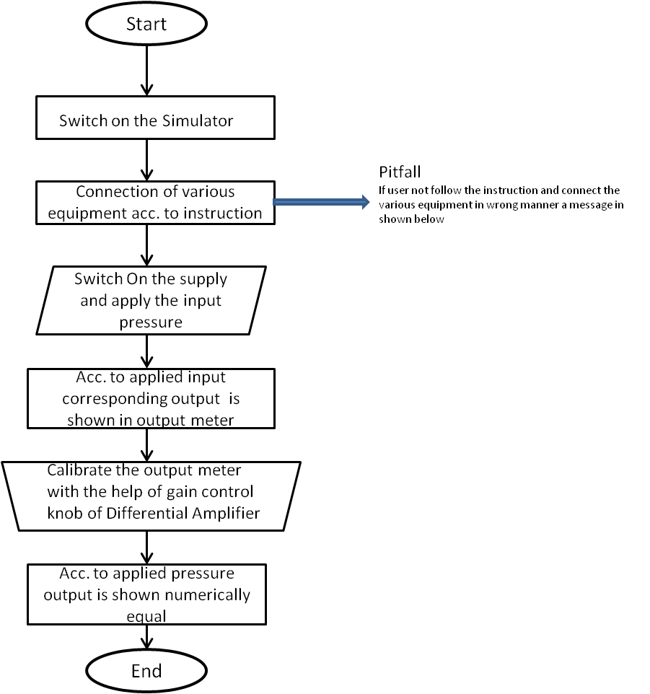

Link to flow chart Here : Store in the /flowchart folder within Round2 folder in your repo  
(guide :The lab proposer should extract logic from the story, prepare a flowchart from the story narration and write the algorithm to execute the black box. use Google Drawings <https://docs.google.com/drawings/> (send the link to your flowchart and also attach .png by exporting it )

**4.Mindmap:**

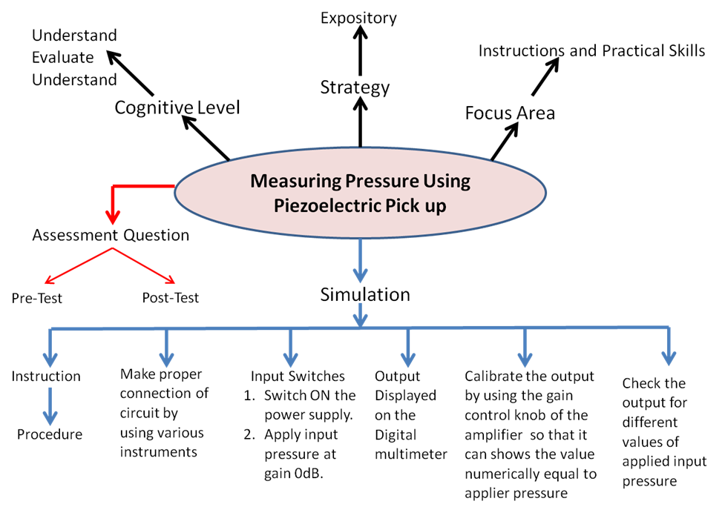

Link to mindmap here : Store the mindmap in both .mm & .png extension in the /mindmap folder and include link of only .pdf verison here  
(guide : An elaborate mind map (connecting all the points in the experiment flow ) should be prepared and submitted by the lab proposer. The mind map should be a clear and detailed document that takes into account all minute intri5acies involved in the development of virtual lab. The mindmap should be self-content and any developer across the globe should be able to code it with all those details. using only FreeMind <http://freemind.sourceforge.net/wiki/index.php/Main_Page> (send the .png file and also the original .mm extension project file. )

**5.Storyboard :**

Link to storybaord (.gif file ) here : (guide: This document should include sketching and description scene wise (duration, action, description). Software to be used for storyboarding : <https://wonderunit.com/storyboarder/> (Its a FOSS tool) . tutorial on how to use it <https://www.youtube.com/watch?v=LAeCEpG0KX4>

Step 1. User will click on the simulation tab then designed simulator opens up.

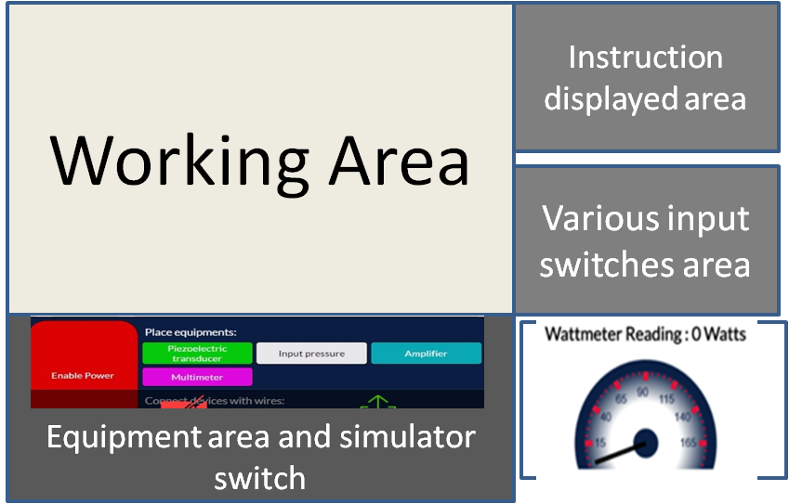

Step 2. Switch on the simulator switch shown in the equipment area and start connecting the equipment and wires according to the instruction displayed in the instruction area.

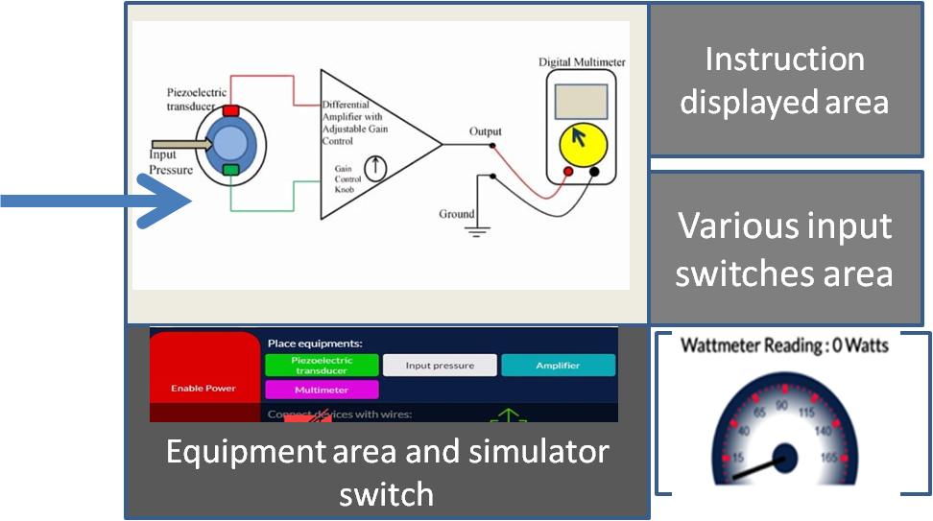

Step 3. Switch ON the supply of the circuit from input switch area and apply the input pressure and then see the output in the output window.

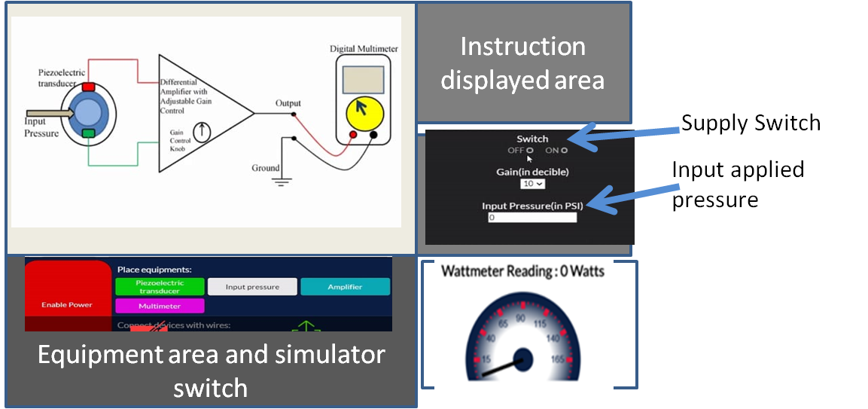

Step 4. Then with the help of gain control knob (shown by arrow) calibrate the output reading as numerically equal to the applied input pressure.

